Ruger 9mm PC Charger Pistol: Full Review

Built with the same platform as the PC Carbine chassis, the Ruger PC Charger Pistol offers the same performance in a compact package which is ideal for self defense.
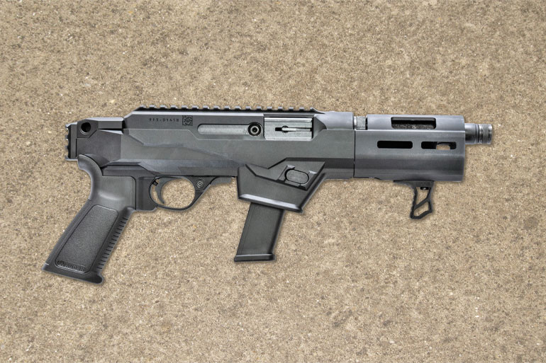
By James Tarr
Ruger has seen huge success with its PC Carbine, and the new PC Charger is a pistol version of the Chassis model of the carbine. Ruger’s PC Carbine Chassis Model came out in 2019, and I wrote it up for RifleShooter magazine, our sister publication. Instead of a traditional stock, the Chassis model sported an AR-style pistol grip and a Picatinny rail at the rear of the gun to which the AR-style stock was clamped.
After studying the takedown barrel and how the stock was attached, it seemed clear that making a pistol version of the Chassis model would be a quick and easy proposition. Just shorten the barrel and swap the stock for a brace or just leave the rail bare. I emailed my contact at Ruger and suggested this, and I learned the project was already in the works. Six months later Ruger announced the PC Charger, and just like Ruger’s new 57 pistol, it seems to be an immediate hit with consumers.
The PC Charger sports a 6.5-inch barrel, a 16.5-inch overall length and a weight of 5.2 pounds. Just like every other version of the PC Carbine, the barrel and handguard quickly detach from the receiver via Ruger’s quick takedown barrel. Once you lock back the bolt, detaching the barrel takes about a second and a half. The barrel is situated inside an aluminum handguard with M-Lok attachment slots at three, six and nine o’clock.
The pistol ships with an interchangeable internal mag well. From the factory it is set up to accept Ruger SR/Security-9 magazines, and one 17-round Ruger magazine is included. Ruger also provides an additional magazine well that accepts double-stack Glock 9mm magazines.
The Ruger magazines work perfectly, but you’re limited to factory capacities, which top out at 17. On the Glock side, magazine options are far more extensive and range from the short 10-round magazines meant for the G26 to the extended 33-round magazines originally built for the select-fire G18—plus the extra-capacity base pads made by TTI, Taylor Freelance, Springer Precision and others. 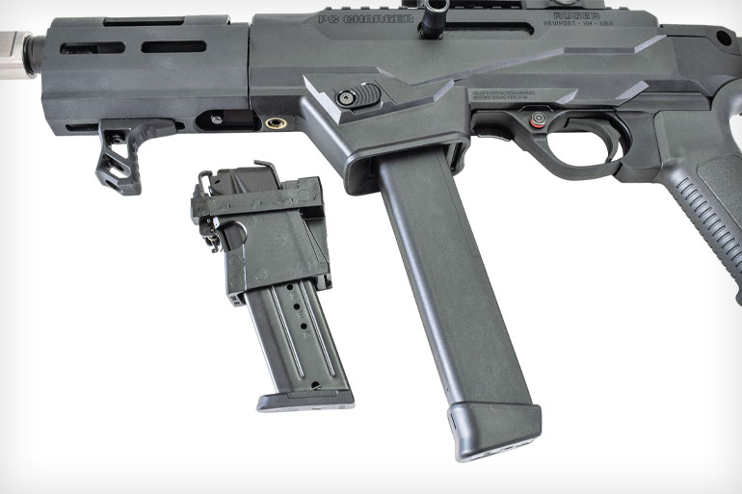
The factory installed magazine well fits the provided Ruger magazine (l.), but Ruger also includes a drop-in well for Glock mags, which are not supplied.
The metal receiver sits inside the polymer chassis, and if you want to swap out the magazine well, you have to undo two bolts: one at the bottom front of the receiver and one at the top rear. The receiver then lifts out of the chassis, and it is inside the latter where you’ll find the magazine well. The mag wells are straight drop-in replacements, and swapping the Ruger for the Glock mag well or vice-versa requires no tools.
An aluminum handstop manufactured by UTG is provided with the pistol, and it’s mounted on the underside of the handguard. At first I found its appearance and positioning odd, then I discovered my support hand fit perfectly between the handstop and the magazine well. The muzzle is threaded 1/2x28 and comes with a thread protector. The receiver with the barrel removed is just 10.75 inches long, making it very compact for storage and transport. The PC Charger uses the same operating system as the longer Carbine. The receiver is exactly the same, only the barrel length and whether it’s a brace or stock at the rear mark the difference.
The trigger is a curved polymer model with a grooved face. Trigger pull on my sample was seven pounds, which is the heaviest trigger pull I’ve ever found on a Ruger PC Carbine/Charger. Most run between five and seven pounds. If you want to upgrade, Volquartsen makes the TG9 trigger pack for this gun, which provides a crisp 2.25-pound trigger pull. 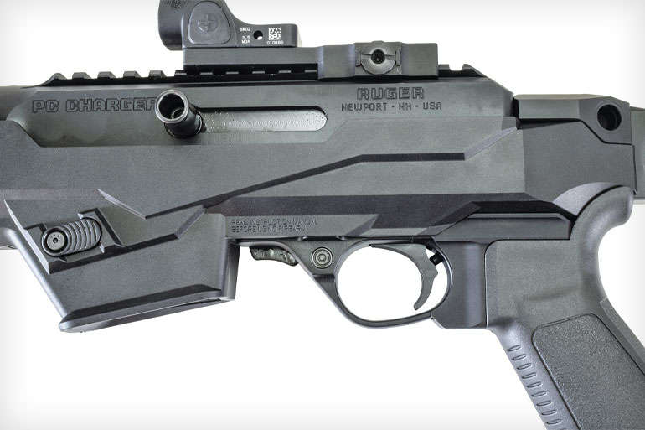
The controls will be familiar to anyone who has shot a 10/22, although here the bolt operating handle and the magazine release can be switched from side to side.
If you’ve ever fired a Ruger 10/22, the Charger’s controls will be familiar to you. The safety is a crossbolt model at the front of the trigger guard. Push it right to left for Fire. The safety cannot be engaged unless the hammer is cocked. It will push most of the way to the right, then stop. You might think the safety is engaged, but it’s not.
The bolt stop is a metal tab just forward of the trigger guard. The bolt locks back on empty magazines, and you can lock the bolt back by pushing up on the tab while pulling the bolt to the rear. As for a bolt release, there isn’t one. You’ll have to tug on the bolt handle to free it from the bolt stop once you’ve replaced an empty magazine with a loaded one.
The magazine release is a simple push-button on the side of the magazine well, and it is reversible. However, unless you’re using current Glock magazines compatible with a reversible mag release, they won’t work if you reverse the mag release.
Most 9mm carbines are straight blowback-operated, and to tame the recoil of the cartridge, weight is added to the bolt. Unfortunately, more reciprocating weight usually means more recoil. The Ruger has a somewhat small bolt, and the distance it travels is short. To control recoil, designers used a sliding tungsten weight inside the bolt that works like a dead-blow hammer, which they refer to as their “dead-blow action.”
The receiver extension and the additional spacer piece directly behind the receiver—which sports QD sling swivel sockets on both sides—are aluminum. The spacer has a vertical section of Picatinny rail, which is left bare.
I would guess almost all buyers will end up clamping an arm brace onto that section of rail, and for testing I attached a side-folding FS1913 brace from SB Tactical, the original inventors of the arm brace. There are three slots in the pistol’s rear rail, so you can adjust the height at which you mount whichever brace you elect to attach. Gear Head Works has a new side-folding brace as well that works great with this pistol.
The bolt handle is reciprocating; it cycles with every shot fired. As it comes from the factory, the bolt handle is on the right side of the gun. I quickly swapped the bolt handle to the left side of the gun so I could work it with my non-firing hand. I am awash in Glock magazines, so I installed the Glock magazine well, although I did test the pistol with both Glock magazines and Ruger magazines. No sights are provided with the Charger, and to be honest, the 6.5-inch sight radius is a bit short for a set of AR-15-style flip-up sights. For most of my shooting, I installed a Trijicon SRO in a low Midwest Industries QD mount. As for what height your optic should be, the answer to that is…it depends.
If you’re not using an arm brace and are just shooting the pistol offhand, you can use an optic of any height you’d like. If you do install an arm brace and happen to shoot this pistol off the shoulder—something the ATF has stated is legal as long as you do not modify the brace—an optic set up for a flattop AR rail might be a bit high. A mini red dot mounted directly to the rail might be a bit low for braced shooting.
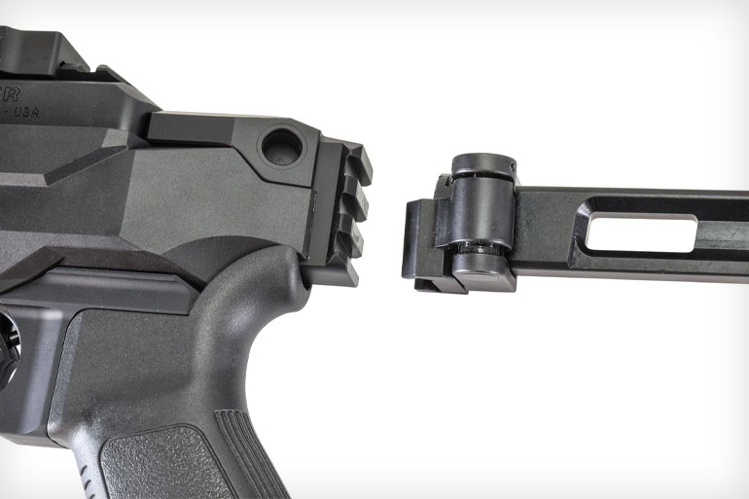
Luckily, there are three slots on the rail at the back of the pistol, allowing you to adjust the height of the arm brace slightly. I found mounting my FS1913 brace as low as possible, combined with the big window of the Trijicon SRO, worked perfectly. A word of caution. The bolt handle is up high on the receiver, so if your optic mount has screws or bolts that stick out the side, be careful you don’t skin your knuckles on them when working the bolt handle. Another bolt handle note: I switched my bolt to the left side of the gun and then installed a brace that folds to the left side—where it can’t fold completely flat because of the bolt handle. Oh well.
As it comes from the factory, this pistol looks a bit awkward to me. But bolt an arm brace on the back, mount an optic and insert an extended magazine, and suddenly it looks like a completely different gun. A far sexier one. Ruger’s PC Carbine has proven itself to be a soft-shooting, reliable gun, and my two near-adult sons and I put more than 300 rounds through my PC Charger before I got around to accuracy testing. We ran the plate rack at the local gun club dozens of times, hammered multiple USPSA silhouette targets, and just generally had a great time.
This is a very fun gun to shoot. Even though this pistol is lighter than most pistol-caliber carbines, felt recoil is the same or less, which means the dead-blow action works as advertised.
We burned through a huge chunk of my 9mm ammo supply—full metal jackets, jacketed hollowpoints, some of the Federal polymer-coated Syntech ammo—and the Ruger ate it all without a hiccup. We shot the Charger so much and so fast we actually got the handguard hot, which is quite a feat when shooting pistol ammo. With hotter +P ammo, you’ll often see significant velocity increases out of the 6.5-inch barrel.
When shooting it without a brace, or with the brace strapped to your arm, you’ll get the best results using the push-pull method. Pull back with your firing hand and push forward on the handguard with your support hand. Even with a short barrel this pistol was as accurate as some full-size carbines I’ve tested, which means you can shoot it far more accurately at distance than you can a standard handgun.
Magazine changes are quick if, while grabbing the spent magazine with your support hand, you hit the mag release with your thumb. After inserting a fresh magazine into the nicely beveled mag well, bring that hand up to tug on the bolt handle if you’ve moved it to the left side. You can do all this while keeping a firing grip on the pistol.
Ruger has seen huge sales with its PC Carbine, and some of those have been to USPSA/IDPA competitors. As a result, a number of companies now offer upgraded parts and accessories for the gun suitable for a variety of endeavors, and just about every piece meant for the Carbine will fit on the Charger. I wish Ruger had put an actual muzzle device on the PC Charger instead of a thread protector. I expect only a few purchasers will actually mount a suppressor, whereas every buyer would benefit from the performance of a muzzle brake. Anything would look better than the stubby muzzle of the factory gun.
On that same range trip with my kids, I taught the girlfriend of one my sons how to shoot. While she struggled to hit anything with a standard handgun, when she used the brace-equipped PC Charger with its Trijicon SRO, she was able to shoot a plate rack at a steady pace. That dramatically improved her confidence.
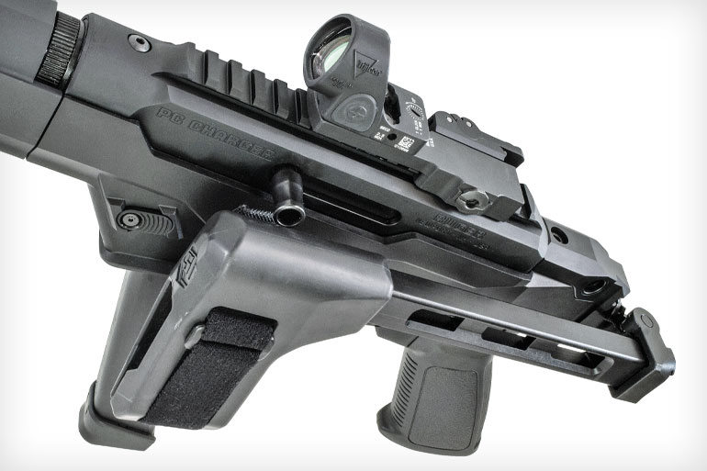
If you switch the bolt handle to the left side and then install a brace that folds to the left, the brace won’t fold flat.
Red dots often help new shooters, as does the extra point of contact provided by the brace. This teenage girl went from barely being able to hit a man-size target at 10 yards to smoothly running a plate rack. This is why I recommend PCCs for home defense: Recoil is less, while hit probability skyrockets, no matter your skill or stress level.
Ruger told me a number of police departments have purchased the PC Carbine, and the company expects to see a lot more interest in the new SBR version of the PC Carbine, which is basically the PC Charger with a stock clamped on the back instead of a brace. As a defensive arm, the PC Charger has a lot of utility. Ruger’s new PC Charger is reliable and great fun to shoot no matter what you have in mind for it, and it breaks down into a tiny package for storage or transport. And just like every version of the PC Carbine, it’s reasonably priced. I liked my sample PC Charger so much I’m buying it.

Ruger PC Charger Specs
- Type: “Dead-blow” blowback-operated semiauto
- Caliber: 9mm Luger
- Capacity: 17-round Ruger magazine included; Glock mag well supplied
- Barrel: 6.5 in., 1:10 twist, threaded 1/2x28
- Overall Length: 16.5 in.
- Weight: 5.2 lb.
- Receiver: Anodized 7075-T6 aluminum
- Furniture: Aluminum handguard w/M-Lok slots; Ruger pistol grip
- Trigger: Single stage, 7 lb. pull
- Sights: None; Picatinny rail

